Digital Learning Across Boundaries: Immersive technologies supporting changemaking in an international context.

Introduction and review of Literature
The DLAB project addresses the need to align European educational practice with ways in which digital technology is changing how and what we learn, and how this is applied in education. In pursuing these goals, DLAB is inspired by the changemaker movement, which seeks to build the skills and attributes for individuals to find innovative solutions to society’s challenges. Key themes of the project are developing changemakers and social innovation education. A third theme is the use of innovative digital learning environments, including immersive technologies such as augmented and virtual reality (AR and VR), to blend physical and digital learning environments and provide powerful opportunities for international collaboration. In this way, the project brings together two aspects of the maker movement: digital making and change making. We sought to explore the impact of this combination, using the social problem of physical inactivity and the potential solution of exergaming as the context for changemaking.

The DLAB project participants are around fifty university lecturers, student teachers, and school teachers, together with ten classes of school pupils across five European countries. Over three years, members of this team will collaborate at a distance to explore three types of 'learning across boundaries’ challenges (physical, personal and environmental) through a process of discovering a problem, empathising with the people involved, and then designing, developing and delivering prototype solutions, a process that has much in common with design thinking (Welsh & Dehler, 2013). This paper focuses on the work of one sub-group, consisting of four paired classes of children in England, Norway and Denmark supported by teams of student teachers, teachers and university lecturers, from the first year of the project who undertook the challenge of crossing physical boundaries. Inspired by the Sports Innovation Campus at Howest University in Bruges, these participants collaborated to invent and share prototype exergames that reversed the negative association of technology with physical inactivity.

Use of technologies
Technology supported the development of mutual understanding between participants from the three countries at the beginning of the year as they used various tools to get to know each other. These social activities included:
● the exchange of seasonal greetings through the creation of AR Keynote GIFs triggered by the app EyeJack;
● swapping 360° stills and videos of their classrooms and creating 360° tours of each other’s local environments;
● sharing virtual meals in AR and VR via CoSpaces;
● exploring landmarks in each other’s countries in 360° through Google Earth tours.

Participants continued to exchange digital artefacts across the countries during designated ‘international days’ when they worked synchronously on their projects throughout the day and kept touch using video communication and Twitter.

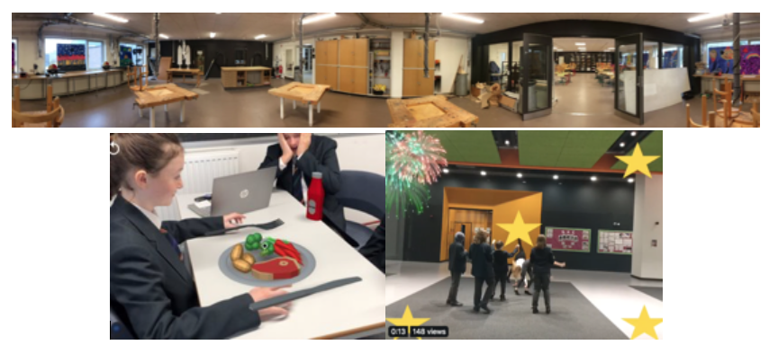
Figure 1: Use of technologies for getting to know each other

Three international days were planned, each with pre and post phases of activity in the schools. During the international days, pupils were introduced to the concept of changemaking and created word clouds illustrating their thoughts using the tool Mentimeter synchronously across the countries.

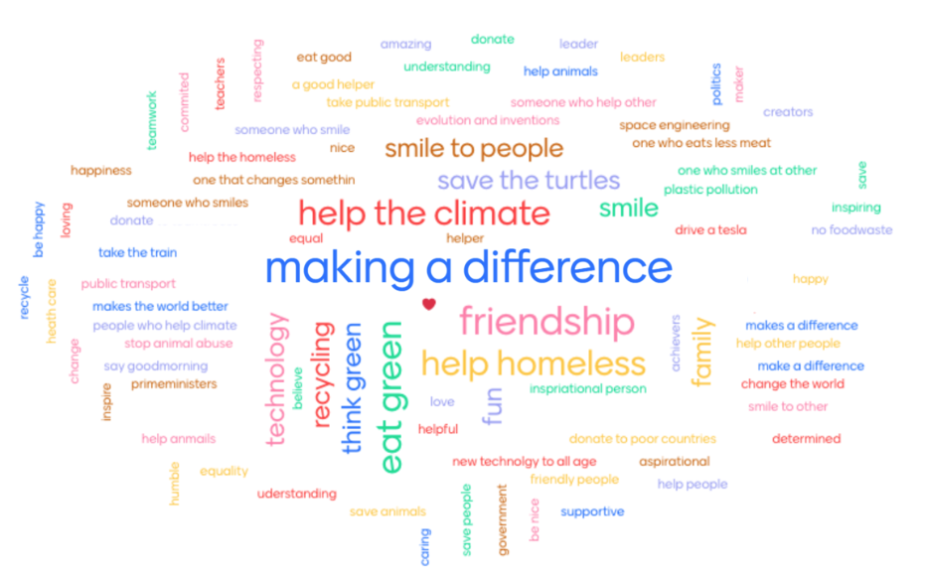
Figure 2: What is a changemaker in your country?

Pupils and university students experimented with a range of technologies to create exergames to share with their international partners. Their invented games included:
● combining the app Plankpad with balance boards and VR headsets;
● creating a soccer video sensing game using a webcam in the coding environment Scratch;
● challenging international partners to explore an environment with the Cardboard Camera app;
● playing a giant human Pac-Man game using MakeyMakeys connected with electric fence string and tin foil;
● creating basketball coaching videos in VR;
● remixing a balance board challenge using Microbits and Scratch.

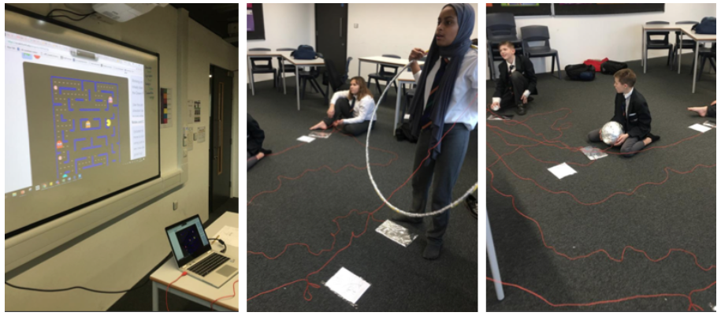
Figure 3: Human Pac-Man game

The final challenge of this strand of the project was to ‘design a prototype digital artefact that draws from artificial realities to stimulate physical activity and addresses the issue of young people’s addiction to online games’. It was planned to use a set of HTC Vive kits with hand-held controllers at the university to invent an ideal exerspace environment populated with prototype exergames for the international partners to experience in 360° using their own mobile devices. However, due to the Covid-19 pandemic, this was trialled by lecturers and university students but not extended to the school pupils. Students and lecturers used the VR app Tilt Brush to ‘paint’ a 360° environment and experimented with importing 3D objects using the tools Google Poly, Google Blocks and CoSpaces to design exergames within it. It was agreed that there was potential in using this combination of tools to design prototype solutions to a range of changemaker challenges.

These examples illustrate some ways in which digital making can support changemaking. They combine to make a set of digital tools and strategies for connecting classrooms and enabling participants to jointly create prototype artefacts and environments that represent innovative solutions to the issue of physical inactivity.

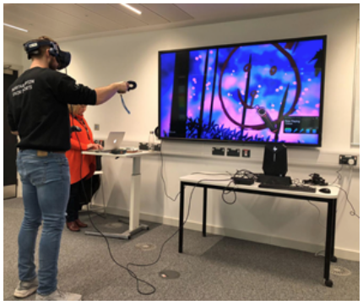
Figure 4: Designing a 360° exergaming environment

The research
The research strand of the project investigated themes of technology supporting school pupils’ development of intercultural awareness, and changemaker attributes and impact across the English team who were paired with classes in Norway and Denmark. The English team consisted of four university lecturers, six university students, two teachers and two classes of 11 and 12 year old pupils. Research data includes photo elicitations, observations and focus group interviews with pupils collected before, during and after participation in the international days in schools.

In analysing the data we sought to answer the following questions:
- Can digital technologies, such as VR and AR, help school pupils to develop changemaker attributes and impact?
- How is changemaking demonstrated in practice by school pupils through the use of digital technologies?
- Does technology-supported changemaking influence the development of intercultural awareness?

Conceptual framework
We review literature pertaining to the use of AR and VR technology in physical activity settings in schools, relating this to the notion of changemakers and how skills associated with changemaking are acquired. To synthesise these themes in the context of this study, we explore the potential for AR and VR technologies to engender physical activity and changemaking, and to contribute to developing the intercultural empathy and social innovation skills that many consider to be crucial aspects of 21st century learning (UN, 2015).

Defining Changemaking
Changemaking can be defined as a process of designing, refining, implementing and evaluating an innovation (Thorogood et al., 2018). Changemaking activities promote the development of ‘soft skills’ that are not easily taught, including project management, persuasion, teamwork and leadership (Thorogood et al., 2018). At the heart of the process is “the active, engaged student who does not passively consume knowledge but who is active in creating it” (Thorogood et al., 2018, p.544). Similarly, Alden Rivers, Armellini, Maxwell, Allen, and Durkin (2015) recognise the complex nature of changemaking, highlighting the ability to identify an issue and take positive action as one of an array of relevant attributes. They too make strong links between changemaking and employability, whilst noting that changemaking places a greater emphasis on empathy, creativity and reflection (Alden Rivers et al., 2015, p.3). Whilst changemaker skills are not necessarily new, they are contemporary, as there is “an expectation for young people to be the social leaders and innovators of tomorrow” (Alden Rivers et al., 2015, p.11) .

The studies cited above emphasise the combination of empathy for others with the motivation to take creative action to solve problems, and recognise that this ability is favoured by employers. If we add in digital competencies, the resulting skill set is consistent with the transformative ambitions of the United Nations (UN) Sustainable Development Goal (SDG) 4.7 which promotes sustainable development and global citizenship (Mochizuki, 2019; UN, 2015). This combination of skills is recognised by Hughes and Maas (2017, p.153), who explored the use of AR and VR with marginalised young people. They found the addition of technologies enhanced students' ability to collaborate and communicate, and helped develop resilience and problem solving, which they termed ‘transferable life skills’. Their approach aligns with the DLAB project in making links between digital making and changemaking.

Intercultural competence
SDG 4.7 recognises the importance of intercultural awareness and sensitivity in an increasingly globalised and multicultural world (Mochizuki, 2019; UN, 2015). Intercultural competence can be defined as “the skills needed to function effectively in interactions with people who differ from an individual linguistically or culturally” (Dziedziewicz, Gajda, and Karwowski, 2014, p.32). Importantly, it develops sensitivities around gender and diversity, making links with changemaking which similarly emphasises empathy, tolerance, respect and appreciation. Dziedziewicz et al., (2014) suggest collaborating with people from different countries and cultures builds creativity and breaks down barriers, however they acknowledge that few such programmes focus on children. The DLAB project adds to the debate about how to build intercultural competence in children and young people by investigating the impact of international teams working together to solve societal problems they have identified together.

Learning theories
The intercultural aspects of the DLAB project have similarities to social constructivist theories of learning, as AR and VR are used to facilitate creativity and collaboration, and the resulting digital artefacts evoke responses from other members of the international teams. Moreover, the digital artefacts facilitate the development of jointly-constructed understandings and shared beliefs. We can also link pupils’ learning to critical learning theory and transformational learning theory, both of which have been identified as having a positive impact on developing changemaker attributes (Alden Rivers et al., 2015). Critical learning theory looks to develop attributes linked with social responsibilities, such as social conscience and empathy, allowing learners to acquire and analyse both social and self-knowledge (McLaren & Crawford, 2010). It encourages learners to develop empathy, critical thinking and civil responsibility (Scorza, Mirra, & Morrell, 2013), attributes that are central to changemaking. Transformational learning theory focuses more on individuals’ learning needs therefore allowing the learner to develop those skills they themselves feel they need to improve. The focus here is on the impact of learners' critical reflection and discussion of their experiences (Fazio-Griffith & Ballard, 2016). Through hands-on experiences and activities, transformational learning allows learners to explore and develop changemaker attributes (Alden Rivers et al., 2015).

AR, VR and physical activity
Our participants identified the social issue of the negative association of technology with physical inactivity as the context for changemaking activities. Literature highlights the risks associated with children and young people’s physical inactivity and, conversely, the well-established benefits of engaging in physical activity. The links between physical activity, chronic disease, mental health and premature death (Department for Health and Social Care [DfHSC], 2019) are clear, and research suggests physically active young people will continue to exercise in adulthood.

Inactivity and the use of digital screens have been linked to sedentary behaviour and resulting adverse impacts upon health. Although only identified as a weak link, the (DfHSC, 2019) associates activities such as ‘watching television, reading, working with a computer, [or] sitting while playing video games’ as sedentary behaviours connected with obesity (Gov.UK, 2017, p.24). However, the rise in gaming which uses controllers that are moved with large bodily movements represents a more positive combination of physical activity and gaming, and has been termed ‘exergaming’ (Faric et al., 2019). Exergaming is particularly appealing to young people (Faric et al., 2019) and there have been many success stories; of note is Pokemon Go which, in 2016, brought AR to the masses almost overnight. Nigg, Mateo, and An (2015) highlighted the potential for Pokemon Go to decrease sedentary behaviour and increase physical activity at both moderate and mild levels, demonstrating the potential for artificial realities to enhance the exergaming experience through immersion.

AR and VR have recently begun to appear in educational contexts (Hughes & Maas, 2017). As Carmigniani et al., (2011, p.342) suggest, VR “completely immerses users in a synthetic world without seeing the real world”. In contrast, AR superimposes information or virtual objects into the real world, allowing a reality where virtual objects seem to coexist in the real environment (Azuma, 1997). Lin and Chang (2015) recognise that these technologies have in the past been cost prohibitive. However, recent advancements have made them more accessible and particularly well suited to use by children. Faric et al., (2019) highlight numerous studies that report increases in intensity of physical activity and higher ratings of enjoyment and interest through AR, noting that the immersive qualities are likely to distract participants from the physical exertion. Similarly, Thornton, Ernst, and Clark observe that AR and VR by their very nature have “the potential to both engage and excite” (2012, p.18). This represents an opportunity within educational settings to embed authentic learning experiences that facilitate cognitive immersion and engagement with physical activity through AR or VR.

Lin and Chang (2015) conducted a small scale study within a special educational needs setting using a body motion interactive game developed in Scratch, and found that the use of AR had a significant and positive effect on children’s physical activity levels. They stress the ease of interaction afforded by AR and suggest that games which rely upon sensory and movement control are more successful and accessible. Hughes and Maas (2017, p.154) also found benefits of AR for children with special needs, including “increased content understanding of spatial structure and function, learning of language associations, long term memory retention, improved physical task performance and increased motivation and engagement”. They conclude that AR and VR appeal to the sensory nature of learning by drawing upon auditory, visual and spatial skills, making it a more immersive experience. As noted by Wu, Lee, Chang, and Liang (2013, p.47), “The nature of these instructional approaches...is quite different from the teacher-centred, delivery-based focus in conventional teaching methods”. The studies cited concur that AR and VR promote active engagement with physical activity and can improve accessibility for many learners.

This conceptual framework sets the scene for our investigation into the potential for digital technologies to support the development of changemaker attributes and impact, including intercultural awareness, in our sample of English school pupils working with their counterparts in Denmark and Norway, supported by the team of student teachers, teachers and lecturers.

Materials and methods
This study employed an ethnographic approach with the intention of gaining rich insights into the role of digital technology in building pupil beliefs and behaviours related to the concept of changemaking (BMJ, 2008). Recognising that cameras and digital images are a constant presence in pupils’ lives and are integral to their visual cultures, we drew from visual ethnography approaches such as photo elicitation to link pupil reflection with the learning contexts (Pink, 2013). This approach acknowledges that visual ethnography can itself be part of the learning process rather than just data collection (Pink, 2013). We sought to use images to empower participants to develop metacognition around the process of changemaking and articulate its impact on their behaviours and beliefs. The added contextual data afforded by the photos aligns with situated learning theory, which views learning as embedded within physical activity, place and culture (Lave & Wenger, 1991).

A second aim of the methodology was to create a participatory research framework that encouraged school pupils and university students to see themselves as co-researchers alongside the teachers and lecturers. This resonates with the work of Thorogood et al., (2018), who found that reconfigured relationships between research participants so that all were seen as equal partners was conducive to changemaking. In our view, the approach increased participants' ownership of the project and engaged them at a deeper level, meaning they were more likely to develop the self-efficacy needed to become changemakers.

The sample for this study included two classes of English Year 7 pupils, supported by two class teachers, six Initial Teacher Training students and four lecturers from the University of Northampton. Our data analysis focuses upon reflections from these pupils, however, their responses are based upon the interactions with their peers in Norway and Denmark. Ethical approval was obtained from the university and BERA (2018) guidelines were followed. All participants were invited to take part in the study, anonymity was guaranteed, and they had withdrawal rights throughout.

Routine tracks of reflection were built into the research process to provide a regular insight into the lived experience of the international days by gathering data before, within and after action. Participants were made explicitly aware of the opportunities to contribute to this reflective cycle (Schon, 1984). The use of pupils’ own photos of their activities increased their autonomy to choose what to share and helped to shift the emphasis away from the researcher-participant dynamic (Kara, 2015). Pupils were asked to take pictures using their phones at points during the international days when they felt particularly motivated, and these were combined in a Padlet. A week after each international day, they chose three photos and wrote briefly about them. These formed the basis for short recorded interviews with students and lecturers. Throughout the international days, the university students made field notes of their observations.
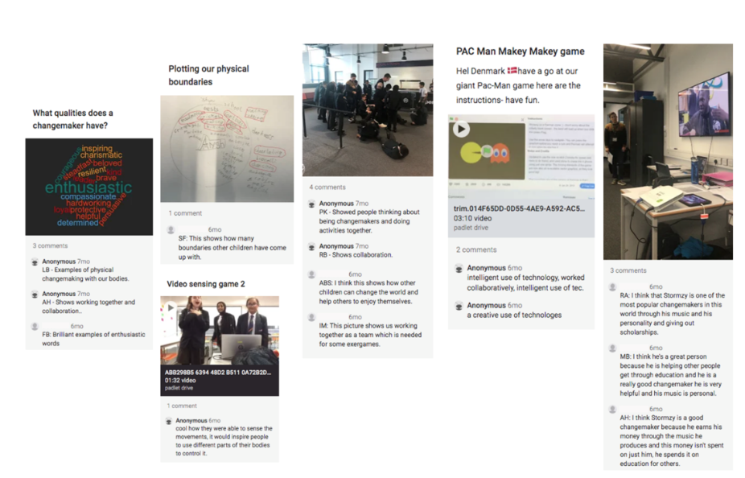
Figure 5: Reflections elicited by photos selected by pupils
Data was thus gathered through several mediums: transcribed individual and focus group interviews with pupils, analyses of images, pupil comments on images, and field notes made by students during the international days. In total, six recorded focus group interviews covering approximately two hours, accompanying images with comments, and three sets of student observations were analysed. The research employed a convenience sampling approach as the schools involved in the project selected two homogenous classes in each country to be involved in the project (Cohen, Manion & Morrison, 2018). The project did not intend to make wider generalisations and the samples were taken from those groups who offered a complete set of data. All decision making throughout the data analysis was based on discussions between the four project researchers, who undertook an iterative process of coding to identify perceptions and opportunities related to the research questions. This process was repeated and modified by team members to ensure consistency and shared understanding of data findings (Strauss & Corbin, 1998).
A deductive method of coding was applied using a set of predefined codes within the software Atlas.ti to identify themes. Initially, a list of changemaker attributes, identified from two sources; ‘Identity, Employability and Entrepreneurship: The ChANGE Framework of Graduate Attributes’ (Maxwell & Armellini, 2019) and ‘More than Simply "Doing Good:" Defining Change-maker’ (Rahman, Herbst, & Mobley, 2016), were used. A total of thirty-seven key words, both positive and negative, were identified from these papers and assigned to the data.

Analysis and Results
The data was examined through an iterative process of thematic coding in relation to the research questions. Initial coding indicated that pupils demonstrated an understanding of other cultures and how they tackled problems and there was evidence of the impact of growing intercultural awareness on how pupils tackled some of the tasks set during the first international day. It was also clear that pupils’ changemaker attributes influenced how they viewed the challenge of using technology to address the issue of physical inactivity. These observations were used to inform a second stage of axial coding that identified relationships between the codes and grouped emerging subsets of categories and overarching concepts. Figure 6 exemplifies how the transcribed quotes are linked to codes and how these are grouped within the category ‘collaborative’. Each category thus relates to a changemaker attribute that groups together a set of original codes. For example, as shown in Figure 7, the category of being ‘empathetic’ includes emotional intelligence, open-mindedness and social intelligence. In total there were fifteen categories that included between two and seven characteristics identified from the data. We then identified how these categories fitted into one of three overarching concepts related to the research questions: changemaker attributes, changemaker impact and intercultural awareness (Figures 7 and 8).
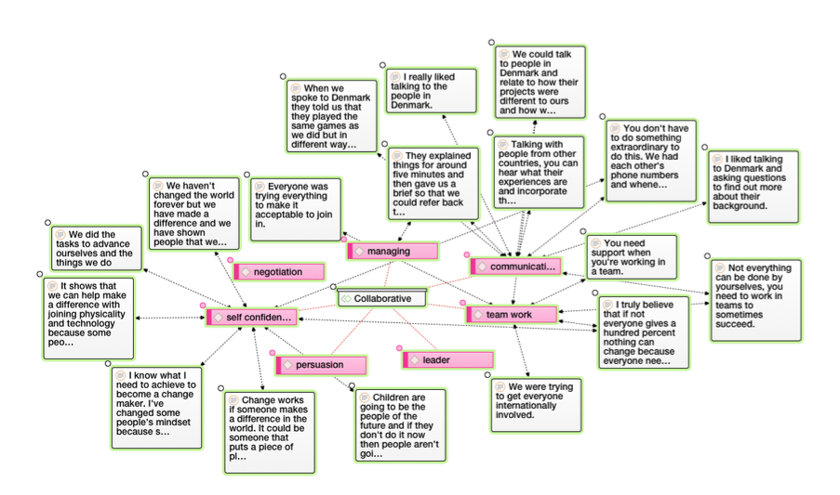
Figure 6: A thematic map of one changemaker category and codes with example quotes
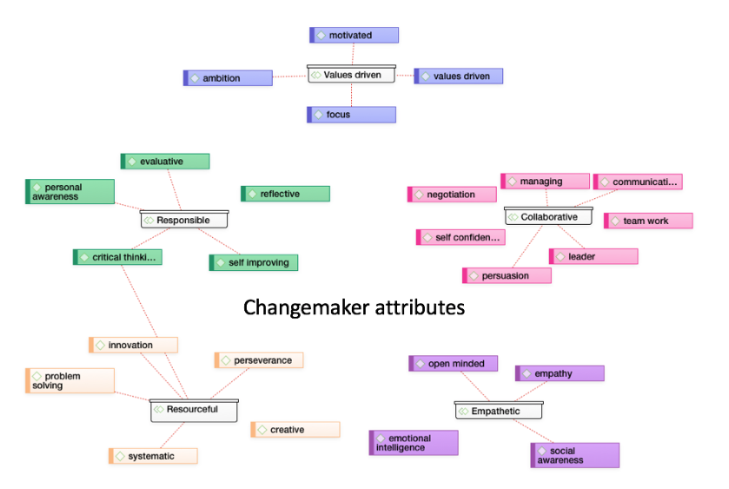
Figure 7: A thematic map of the categories and codes linked to the concept of changemaker attributes
Findings
Concept | Categories | Frequency | Quotes
Changemaker attributes | Responsible, collaborative, resourceful, empathic, values driven | Total 246  Positive 230  Negative 16 | ‘We haven't changed the world forever, but we have made a difference and we have shown people that we can help with the future.’
Changemaker impact | Habits, physical activity, sharing experiences, technology use, raising awareness | Total 212  Positive 194  Negative 128 | ‘Things you use in regular days with technology can be used in different ways to help enhance your life physically.’
Intercultural awareness | Sensitivity, transfer of skills, social conscience, globally aware, curious | Total 359  Positive 340  Negative 19 | ‘Talking to other countries was a good idea because it lets them see what we do in our country and what they do in their country so we can watch how other countries compare to ours. Seeing how they are doing their tasks will help us to understand how we can do ours better.’
Figure 8: A summary of the categories and concepts
In presenting the findings we discuss each overarching concept in Figure 8.
Changemaker attributes
There was a majority of positive responses to discussions around changemaker attributes. By analysing their experiences from the international days, pupils formed a judgement on how what they had learnt could impact themselves or others. They discussed how they were able to collaborate with their international peers using digital communication, and how this enhanced their technological abilities. Pupils shared ideas and felt confident in arguing possible solutions to the exergame challenge. Resourcefulness was shown through the use of video communication and Twitter, and by sharing AR and VR films and images of their environments, to see how their international peers approached the tasks. By doing this, they learnt new ways of approaching problems. Empathy was demonstrated through understanding that change, whilst sometimes difficult, requires togetherness and cooperation to succeed. Pupils exhibited an awareness of some of the issues the world currently faces and a responsibility towards making change happen. Although their challenge focused on using technology to improve physical activity, they were able to apply this thinking to other issues, such as the environment.

‘We haven't changed the world forever but we have made a difference and we have shown people that we can help with the future.’
‘Using technology and physical education…you can do both at once you can do exercise whilst playing video games in your house.’
‘We had to hold hands and interact with each other and you had to speak quite a bit because one person would have one idea and another person another, you'd have to agree on the idea. It really helped us to work together and to work as a team.’
‘Not everything can be done by yourselves, you need to work in teams to sometimes succeed.’
‘You’ve got to think about things before you do it, understand it before you do it.’
‘It helps younger kids like our generation to think that when I grow up am I going to stay the same or am I going to make a difference and make it right? ’

Changemaker impact
Pupils’ views of their changemaker impact was that it was an ambition rather than something they could clearly see had happened. Whilst there was a majority of positive responses, the high number of negative responses suggest pupils seeing changemaker impact as being particularly challenging. They demonstrated an understanding that change must happen for a reason and a willingness to take responsibility in tackling the issue of motivating others to be active using technology. Pupils aspired to personal development and noted that this was an ongoing process which could occur at any point in life. The international days encouraged them to think about how their actions could make a difference in the future. They recognised that digital technology is an everyday part of their lives and understood that it can be used to improve their level of physical activity at school and at home. Making the exergames fun was identified as key to engaging their peers. Pupils noticed that changing the use of technology from entertainment to exercise could impact not only their own lives but everyone else’s too, and they described how they applied their skills to implement change outside school with friends, the school community and family. Altruism was also apparent in their reflections, as they appreciated that they could improve the lives of others without the need for personal recognition.

‘Breaking environmental boundaries would take a lot of effort but if we incorporate that in our daily lives we know we can make a change.’
‘It also makes you feel more aware of your surroundings. Say in a couple of years time with the environmental boundaries breaking down. Would take a lot of effort, but if you incorporate that into our daily lives, we know we can make a change.’
‘Things you use on a regular day with technology can be used in different ways to help enhance your life physically.’
‘I know what I need to achieve to become a change maker. I've changed some people's mindset because sometimes we're not entirely capable of doing things but that doesn't affect who we are as people and what we can do.’
‘Changing people's lives and not even knowing about it would still be great.’
‘Anyone can change the world with a small app. One of the important things to teenagers today and to your life is being able to use technology in a way that is both fun and that helps you to improve the way you live. While being entertained you can still be active using one of the new apps.’
‘Things you do every day for entertainment can really make a change in your life if you just use them in a different way.’
‘It shows that we can help make a difference with joining physicality and technology because some people think just adults can do this but we're showing that children can do as well.’

Intercultural Awareness
The positive responses in this collection of categories indicate that the project had an effect on pupils’ intercultural awareness and the English pupils were keen to work with their international peers (see Figure 8). They were able to listen and respond sensitively to pupils from other countries, and demonstrated an interest in exploring similarities and differences between the cultures and the varying approaches to tackling problems. Their curiosity to see how the children in Denmark and Norway approached the tasks illustrated an openness to different viewpoints. Pupils began to look at everyday technologies in a different light, using them to overcome language barriers by combining text, images and speech in their video calls. They collaborated to make decisions and communicate their ideas, taking time to reflect on each other’s inputs before making a final decision as a group. They understood that problems can be solved through teamwork, listening and negotiating solutions. Empathy between pupils was evident as they showed an understanding that experiences differ and included discussions around the type and accessibility of the technologies for their designs. Being sensitive and socially conscious was also exemplified in practice by their consideration of the other children’s written and spoken English as they thought carefully about how they presented their instructions for non-native speakers.
‘We've got to think about things to make them work and not just do it and put some effort into understanding why we're doing what we're doing.’
‘To help us understand what they do and how similar it is to what we do, but also how different we are.’
‘Talking to other countries was a good idea because it lets them see what we do in our country and what they do in their country so we can watch how other countries compare to ours. Seeing how they are doing their tasks will help us to understand how we can do ours better.’
‘Using simple things like your phone or VR headset allows you to experience things in the world and understand more of the world and see how places you might have never been to and how people live their lives and how enriched they are in those places.’

Discussion and Conclusions
This study explored a model of technology-supported changemaking, with a focus on immersive technologies. Key concepts to emerge from our findings are related to:
● using digital technologies, such as VR and AR, to help school pupils develop changemaker attributes and impact;
● demonstrating the process of digital making supporting changemaking;
● understanding how technology-supported changemaking influences the development of intercultural awareness
Technologies developing changemaker attributes and impact
Pupils encountered technology tools that were new to many of them and there is evidence to show that in developing and applying their skills, they demonstrated a range of changemaker attributes such as resilience, perseverance, negotiation and collaboration (Hughes & Maas, 2017). The immersive technologies, as part of a mix of technologies, not only gave pupils a creative platform through which they could innovate and invent, but facilitated a process through which they could share their work with peers from other cultures and receive feedback in real time. It was evident that participation in the international days encouraged pupils to consider how they could engage in changemaking and they recognised that this could have an impact on themselves and those around them in the future. Additionally, pupils were aware that, for change to be permanent, everyone has to invest in that change. This amounts to a growing understanding of some of the processes involved in being a changemaker.

Digital making supporting changemaking
The DLAB project has taken an innovative approach to the use of AR and VR as a means to empower young people to build understanding of each other’s environments and culture, and to design, build and share prototype exergames. Immersive technologies are increasingly a part of young people’s lives and, through their inventions, our pupils showed that such technologies can be put to positive effect. Some pupils described a change in their attitude towards technology as they moved from a more passive role as consumers to become active innovators, designers and makers, a process that required significant motivation and focus. However, there is the risk that the novelty will wear off and old habits resume or are resistant to change.
There is evidence of both critical learning theory and transformational learning theory in practice, as pupils developed attributes within themselves and within a social setting. Transformational learning experiences were evident where the pupils demonstrated critical discussion of ideas and negotiation skills as part of a team (Fazio-Griffith & Ballard, 2016; Mezirow, 1991; Alden Rivers et al., 2015). Critical learning theory is evident in their ability to demonstrate empathy, civil responsibility and problem solving (Scorza et al., 2013; Alden Rivers et al., 2015; McLaren & Crawford, 2010). As pupils gained metacognition of the changemaking process they developed attributes such as self-efficacy (Scorza, Mirra, & Morrell, 2013).
Technologies supporting the development of intercultural awareness
Our findings clearly show some development of intercultural awareness in the pupils and, in the context of the project, technology created an environment that allowed this to happen. For example, the digital communication tools such as the continuous twitter wall and video conferencing lent an immediacy and interdependency to the collaboration that made it more genuine. As a result, during the international days, pupils were active in the generation of knowledge and solving of problems (Thorogood et al., 2018). Being able to share and discuss ideas virtually enabled them to connect internationally, and their mutual interest led to a developing understanding of their cultures and the differing approaches their partners took to tackling problems (Hughes & Maas, 2017). The pupils understood some of the attitudes, environments and challenges that would face their partner schools and took them into account in their game designs and instructions, demonstrating a combination of critical reflection and design thinking (Welsh & Dehler, 2013).

Limitations
This study was not without its challenges, not least the communication and collaboration between the countries involved. Working as a large international team across time zones and accommodating different ethoses across ten partner institutions presented an ambitious programme. We worked with pupils aged between 11 and 12, who came from a range of international, socioeconomic and educational backgrounds. The variability in experiences means it cannot be assumed that the attributes demonstrated were developed distinctly as a result of the study; there will be cases where some of the attributes demonstrated were already present but were seen to be applied in this context. Overall, we are aware that this research is situational in the context of the project.

Conclusions
This study presents a set of data that suggests the creative application of technologies such as AR and VR can develop changemaker attributes and an understanding of the changemaker process within an international project. The designing and making of AR and VR artefacts is an innovative approach to using these immersive technologies as it advances users beyond a relatively passive experience to being inventors and innovators. The exchange of digital artefacts between the partner countries propelled the process of collaborative problem-solving and prompted the development of intercultural awareness. It is likely that the immersive nature of the VR and AR exchanges firstly gave the partners a more immediate impression of each other’s environments as they exchanged 360° images and videos, and secondly deepened their engagement with their invented exergames. AR enabled the sharing of digital artefacts that were ‘almost physical’ in that they are situated in real places, whereas the telepresence feature of VR instantly enabled the sensation of being transported to another place.

When technologies were applied within the context of exergaming, our pupils demonstrated a range of skills associated with changemaking and were articulate in discussing their various benefits and challenges. Evidence of changemaker impact was demonstrated through their willingness to trial solutions, share their findings more widely and commit to ongoing changes in their own activity patterns. This illustrates the enabling power of the technologies in acting as a catalyst for transformative learning, promoting the aims of UNESCO’s Sustainable Development Goal 4, Target 7 that focuses on promoting sustainable societies and global citizenship through education (UN, 2015).

This study also demonstrates the process of co-creating knowledge through a participatory teaching and research design in which the lecturers, teachers, pupils and student teachers were viewed as equal peers in developing and documenting the changemaking endeavour. This reshaping of the traditional research and teaching relationship proved conducive to changemaking and helped pupils to view themselves as positive agents of change (Thorogood et al., 2018).

In conclusion, we suggest that this study is pioneering in demonstrating that the creative use of immersive technologies, supported by a mix of other technologies, has the potential to create conditions for social innovation education. The use of immersive technology within this study provided an environment for pupils to demonstrate changemaker skills such as empathy, tolerance and respect for other cultures. Through the creation of their exergames, they showed that they were aware and concerned about the issue of technology's contribution to sedentary behaviour and had the self-efficacy to be proactive in designing engaging technology-based solutions.

Recommendations
This study provides compelling evidence that there is potential for technology-enabled changemaking in an educational setting. Equipping pupils with the skills to instigate change by inventing technology-based solutions was a powerful theme. There is much to be learnt in how this can be more widely employed across a range of educational settings and demographics of young people. Furthermore, it is evident that technology remains an intrinsic part of young people’s worlds and is a highly motivating learning tool. Whilst immersive technology use in schools is in its infancy, this study indicates there is a willingness and excitement to develop it as a learning tool and pedagogical approach. We also identify the potential to develop exergaming in relation to health, physical activity, sport and physical education on a wider scale.

This study highlights an opportunity to explore other social and environmental issues through AR and VR, as was undertaken by the other three sub-groups within the DLAB project this year. It also offers a chance to explore the changemaking impact that working in an international study has over time. The DLAB: Developing Changemakers project now moves into its second year and will be exploring how technologies might be used to address personal challenges that our participants face, a theme that is particularly relevant in the light of the recent adoption of increased remote studying and working.

Bibliographical references
Alden Rivers, B., Armellini, A., Maxwell, R., Allen, S., & Durkin, C. (2015). Social innovation education: towards a framework for learning design. Higher Education, Skills and Work - Based Learning, 5(4), 383-400.
Azuma, R. (1997). A survey of augmented reality. Presence: Teleoperators & Virtual Environments, 6(4), 355-385. Retrieved from https://www.mitpressjournals.org/doi/pdf/10.1162/pres.1997.6.4.355
BERA (2018). Ethical Guidelines for Educational Research. Retrieved from https://www.bera.ac.uk/publication/ethical-guidelines-for-educational-research-2018
BMJ (2008) Qualitative research methodologies: ethnography. The British Medical Journal, 337,a1020. doi: https://doi.org/10.1136/bmj.a1020
Carmigniani, J., Furht, B., Anisetti, M., Ceravolo, P., Damiani, E., & Ivkovic, M. (2011). Augmented reality technologies, systems, and applications. Multimedia Tools and Applications, 51(1), 341–377. doi:10.1007/s11042-010-0660-6
Cohen, L., Manion, L., & Morrison, K. (2018). Research Methods in Education. London: Routledge.
Department for Health and Social Care (2019) UK Chief Medical Officers' Physical Activity Guidelines. Retrieved from https://www.gov.uk/government/publications/physical-activity-guidelines-uk-chief-medical-officers-report
Dziedziewicz, D., Gajda, A., & Karwowski, M. (2014). Developing children's intercultural competence and creativity. Thinking Skills and Creativity, 13, 32-42.
Faric, N., Yorke, E., Varnes, L., Newby, K., Potts, H.W., Smith, L., Hon, A., Steptoe, A. and Fisher, A., (2019). Younger Adolescents’ Perceptions of Physical Activity, Exergaming, and Virtual Reality: Qualitative Intervention Development Study. JMIR Serious Games, 7(2), p.e11960.
Fazio-Griffith, L. & Ballard, M. B. (2016) Transformational Learning Theory and Transformative Teaching: A Creative Strategy for Understanding the Helping Relationship. Journal of Creativity in Mental Health, 11(2), 225-234.
Gov.UK (2017). Childhood Obesity: A Plan for Action. Retrieved from https://www.gov.uk/government/publications/childhood-obesity-a-plan-for-action/childhood-obesity-a-plan-for-action
Hughes, J. & Maas, M. (2017). Developing 21st Century Competencies of Marginalized Students Through the Use of Augmented Reality (AR). LEARNing Landscapes, 11(1), 153–169.
Kara, H. (2015). Creative research methods in the social sciences: A practical guide. Bristol: Policy Press.
Lave, J. and Wenger, E. (1991). Situated learning: Legitimate peripheral participation. Cambridge: Cambridge University Press.
Lin, C. Y., & Chang, Y. M. (2015). Interactive augmented reality using Scratch 2.0 to improve physical activities for children with developmental disabilities. Research in Developmental Disabilities, 37, 1-8.
Maxwell, R. & Armellini, A. (2019). Identity, employability and entrepreneurship: the ChANGE framework of graduate attributes. Higher Education, Skills and Work-based Learning, 9(1), 76-91. Retrieved from https://www.emerald.com/insight/content/doi/10.1108/HESWBL-02-2018-0016/full/pdf?title=identity-employability-and-entrepreneurship-the-change-framework-of-graduate-attributes
McLaren, P. & Crawford, J. (2010). Critical pedagogy. In C. Kridel (Ed.), Encyclopedia of curriculum studies (pp. 148-149). California: SAGE.
Mezirow, J. (1991). Transformative Dimensions of Adult Learning. San Francisco , CA: Jossey-Bass.
Mochizuki, Y. (2019). Rethinking Schooling for the 21st Century: UNESCO‐MGIEP's Contribution to SDG 4.7. Sustainability: The Journal of Record, 12(2), 88-92.
Nigg, C., Mateo, D., & An, J. (2015). Pokémon GO May Increase Physical Activity and Decrease Sedentary Behaviors. American Journal of Public Health, 107(1), 37-38. https://doi.org/10.2105/AJPH.2016.303532
Pink, S. (2013). Doing visual ethnography (3rd ed.). London: SAGE.
Rahman, R., Herbst, K., & Mobley, P. (2016). More than simply “doing good:” A definition of Changemaker: what children, truckers, and superheroes all have in common. Retrived from https://issuu.com/ashokachangemakers/docs/more_than_simply_doing_good_definin/10
Schon, D. A. (1984). The reflective practitioner: How professionals think in action. New York: Basic books.
Scorza, D., Mirra, N., & Morrell, E. (2013). It should just be education: critical pedagogy normalized as academic excellence. International Journal of Critical Pedagogy, 4(2), 15-34. Retrieved from http://libjournal.uncg.edu/ijcp/article/view/337/365
Strauss, A., & Corbin, J. (1998). Basics of qualitative research techniques. Thousand Oaks, CA: Sage publications.
Thornton, T., Ernst, J. V., & Clark, A. C. (2012). Augmented reality as a visual and spatial learning tool in technology education: Potential exists for AR to be incorporated in not only STEMeducation, but across all disciplines. Technology and Engineering Teacher, 71(8), 18-21.
Thorogood, J., Azuma, F., Collins, C., Plyushteva, P., & Marie, J. (2018). Changemakers and change agents: encouraging students as researchers through Changemaker’s programmes. Journal of Geography in Higher Education, 42(4), 540-556. DOI: 10.1080/03098265.2018.1460804
UN. (2015). Transforming our world: The 2030 Agenda for Sustainable Development. A/RES/70/1. New York: UN. Retrieved 23 July 2020 from https://sustainabledevelopment.un.org/post2015/transformingourworld
Welsh, M. A., & Dehler, G. E. (2013). Combining Critical Reflection and Design Thinking to Develop Integrative Learners. Journal of Management Education, 37(6), 771–802. https://doi.org/10.1177/1052562912470107
Wu, H., Lee, S. W., Chang, H., & Liang, J. (2013). Current status, opportunities and challenges of augmented reality in education. Computers & Education, 62, 41–49. doi:10.1016/j.compedu.2012.10

